Bilkent University

Department of Computer Engineering

Object Oriented Software Engineering Project

Project short-name: Mr.&Mrs. Pac-Man Ext.

Final Report

Ecem İlgün, Aziz Osman Kozhan, Başak Şevval Ekici, Talha Şeker

Supervisor: Bora Güngören

Dec 16, 2017

This report is submitted to the Department of Computer Engineering of Bilkent University in partial fulfillment of the requirements of the Object Oriented Software Engineering Project course CS319/2.

Contents

1. Changes in Implementation3

2. About the Project 5

**2.1 Current Status of the Project 5**

**2.2 Detailed Object Design7**

3. User’s Guide8

**3.1 System Requirements8**

**3.2 Installation8**

**3.3 Overview of the Game9**

**3.4 Game Entities Subsystem12**

**3.4.1 Game Screenshots12**

**3.4.2 Controls16**

**3.4.1 Game Objects16**

**A Appendix.17**

**1. Changes in Implementation**

We generally sticked to our first implementation model which is planned as three layers, but we made some minor changes in the classes.

In GUI layer, we tried to optimize the class structure as much as we can. So in order to achieve that, we determined the unnecessary panels and changed them to more practical implementations. Before, when user paused the game and wanted to save it, he was going to another panel SaveGamePanel, which was just created for saving the game. Also when user creates his own map, he was going to SaveGamePanel. After the changes, a single JoptionPane handles saving operation now. Also, LoadGamePanel and LoadMapPanel are also changed to a JoptionPane. Now when the user wants to load the game, the option pane comes with a list of last saved maps or games, and the user select from them and play. This alteration make the game more userfriendly too because changing the whole panel was creating distraction for the user. Another change in GUI part is the pause menu that comes when the user pauses the game. Before, it was covering the entire screen, but now it is in the middle of the screen, with the view of paused game screen at the background. This change makes this process more practical. Another change is in the AnimationManager subpackage. It is understood that the ghost animations does not require a complex implementation and therefore a separate GhostAnimation class is unnecessary and we exclude it. In PacmanAnimation class, we made a different implementation ir order to minimize the written code. Instead of writing different methods for each movement, we managed to do that in one method by taking an argument from PacmanAnimationType enumeration. Lastly we add a new panel called NewScorePanel, which is asking the user if he wants to save his highscore.

For the data layer, the saving technique we used in database is changed. Instead of saving all the properties of the object one by one to a text file, we save it as a complete object with Object Output Stream, to a binary text file. This decreased the written code and minimized the work done. To make appropriate seperation between saved games and saved maps, we used different extensions and changed the constructor of GameEngine class. Saving the game includes “.game” and saving map includes “.map” extensions in the system of the game. It is basically a single String operation and it helps to avoid any possible conflict for the reading and writing of saved game and created map. In the constructor, the GameEngine determines whether it is a saved game or created map and so builds the game according to that. And there was another change in GameData. In order not to lose the objects of the initially created map, we implemented the GameData in order to store the information of both played and the initial created map. With this, we were able to pass all the objects to the next level without losing any data.

At the Game Logic layer, there are again some minor changes, not mostly in the structure, but in the class implementations of the game. For the shield classes, the features we gave to the shield types has changed in order to make it a bit more challenging and to increase the quality of the game. The CopperShield now is active for 15 seconds and allows the Pacman to only go through the ghosts without losing life. For the SilverShield, the active time for the Shield is 20, and lastly for the GoldenShield it is 15 seconds but the speed of the Pacman increases to its double. We have collapsed children classes of Food into one class, since none of their methods differed and all their differences could be managed by knowing FoodType enumeration. GameEngine class became a singleton class to avoid pass by value problems. All the classes should be reaching to the same version of the objects of the class and to manage that we made this choice of design. A structral change is made in order to strengthen the hierarchy between TimeController, updateService, GhostController and InteractionCheckerAndHandler classes. UpdateService is an attribute to TimeController class to handle the classes and call their methods more easily. Again in the same way, GhostController and InteractionCheckerAndHandler are the attributes of the UpdateService class. The implementation technique we chose in this new structure was called opaque layering.

**2. About the Project**

**2.1 Current Status of the Project**

Data Layer is functioning as promised. The player can save the game he was playing and load anytime later to continue playing. Again if user created a map, he can save it to saved maps and play the saved map whenever he wishes. The player also can save his high score with a name and can list the full list from the main menu screen.

For the game, the logic behind the game is working properly as well. The ghosts are moving according to their AI algorithm and create an appropriate level of challenge to the player. Ghosts are also escaping in scatter mode with a logical algorithm. The Pacman gets the direction from user and moves according to the input without any delays. Also, the second Pacman works with the first Pacman without any errors. They move appropriately and different users can direct them at the same time. The logic behind the shields is structred well and now shields are functioning without any errors. The features of the shields are working properly. The extra food types are working as promised and give the related side effects to the Pacman. The user can pause and resume the game as he wishes. In the create map, user can change the object of the map array according to his willing. He can also arrange the number of ghost and player with the create map mode. Therefore all the extra features we added to the Pacman game are working conveniently.

For the GUI part, we implemented the game as similar as we promised in our mockups. The used font in the game is the real Pac-man font. We designed the ghosts and the Pac-mans as closer as the original. We have made some changes in the appearance of Pac-man with shield mode. Also for the different food types, we designed different icons. We created an animation of Pac-man and ghosts at the beginning of the game. Moreover, the animations of Pac-mans and ghosts are done including ghosts’ scatter mode animations. In the create map screen, there is a grid structure behind the map. Hence, the user is prompted to place the object to the proper places. All the promised features in terms of GUI are done properly as well.

**2.2 Detailed Object Design**

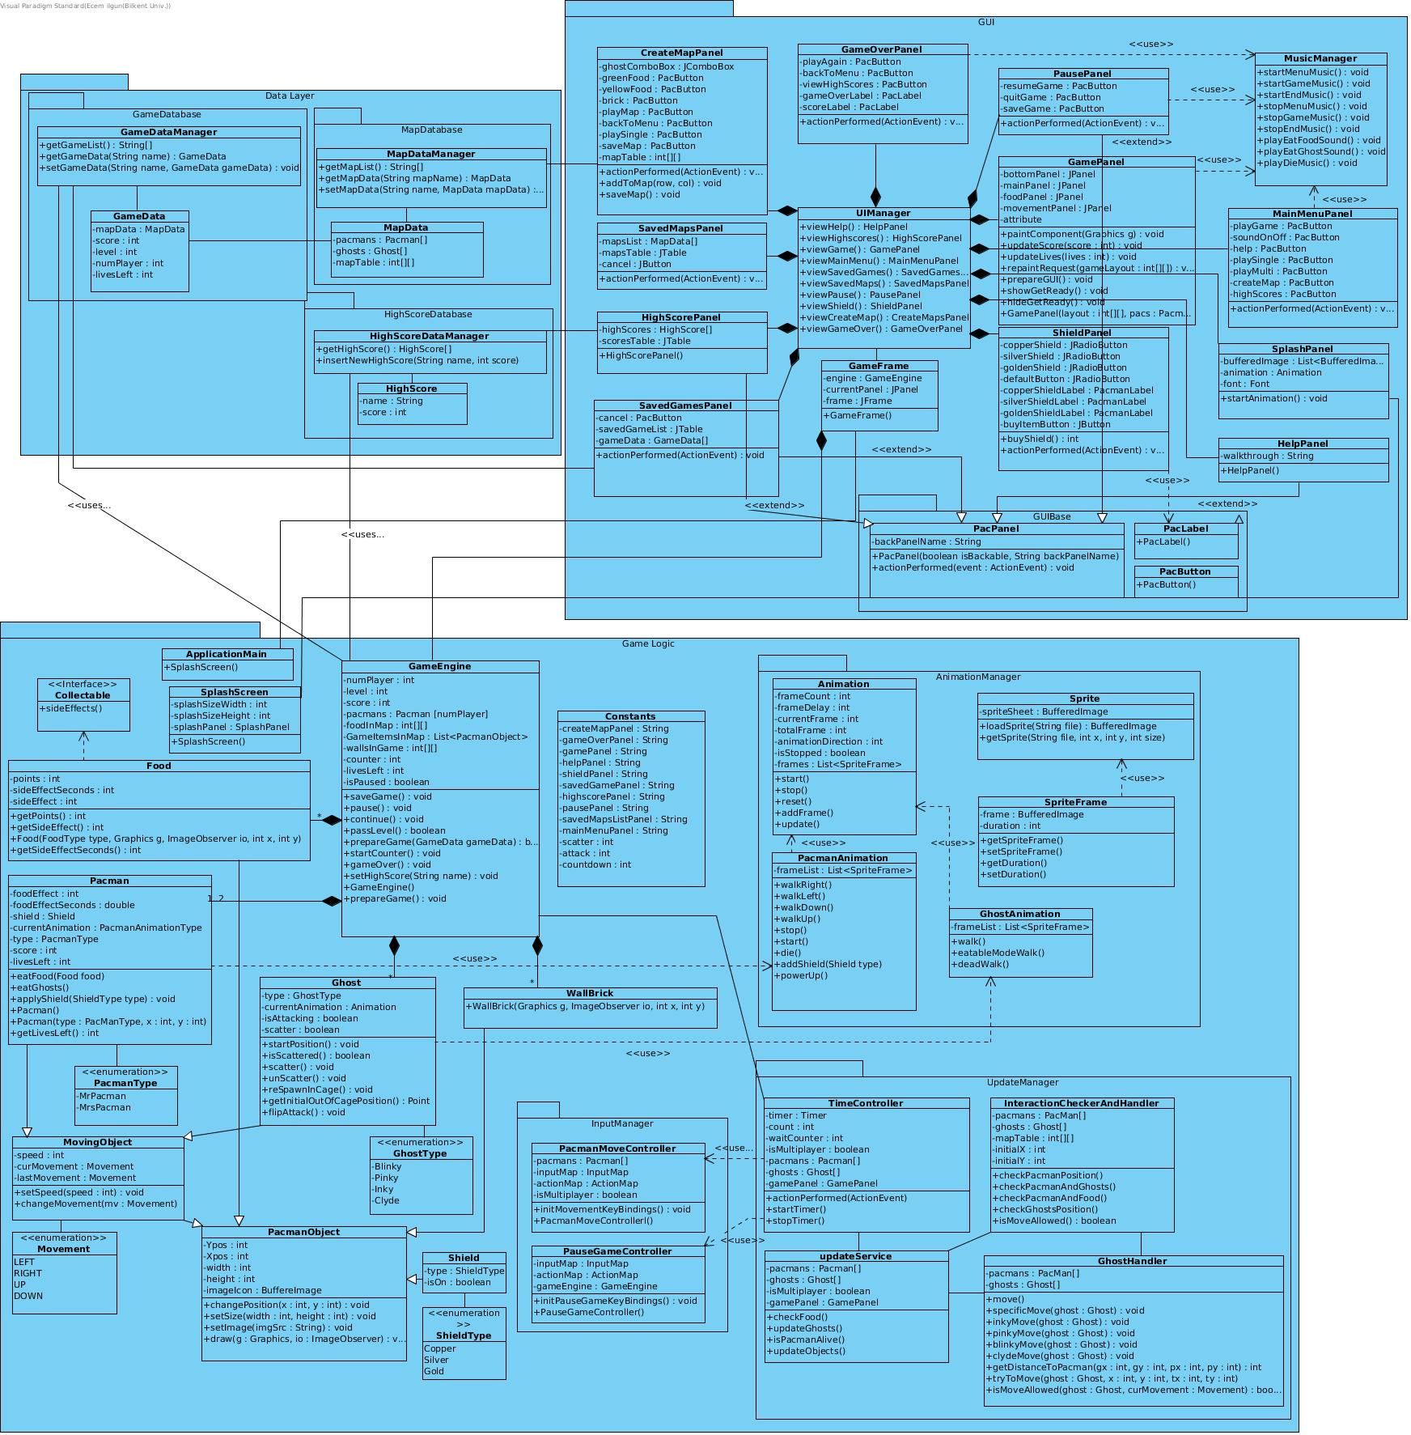

**3. User’s Guide**

Mr.&Mrs. Pac-man Extended is a Java based arcade game. Therefore, to launch the game, user must have Java Runtime Environment (JRE), which can be easily found from this [link](http://www.oracle.com/technetwork/java/javase/downloads/jre8-downloads-2133155.html). The game can be launched in common operating systems.

**3.1 System Requirements**

*Recommended System Requirements:*

• Windows 10, Linux, MacOS

• Intel core 2 duo 1.6 GHz CPU or higher

• 256 MB of RAM or higher.

• Screen Resolution: 800x600

**3.2 Installation**

Clicking its .jar extension launches the game. However, compiling and running the game code with an IDE is a way to launch our game too.

**3.3 Overview of the Game**

When game starts, an animation starts and then main menu screen appears. If player clicks question mark, help screen will appear and player can get information about items.

When player starts the game, he can manage Pac-man icon. If user selected multiplayer mode, the second person can also manage Mrs Pac-man with related keys. There is a picture of the starting for multiplayer game below.

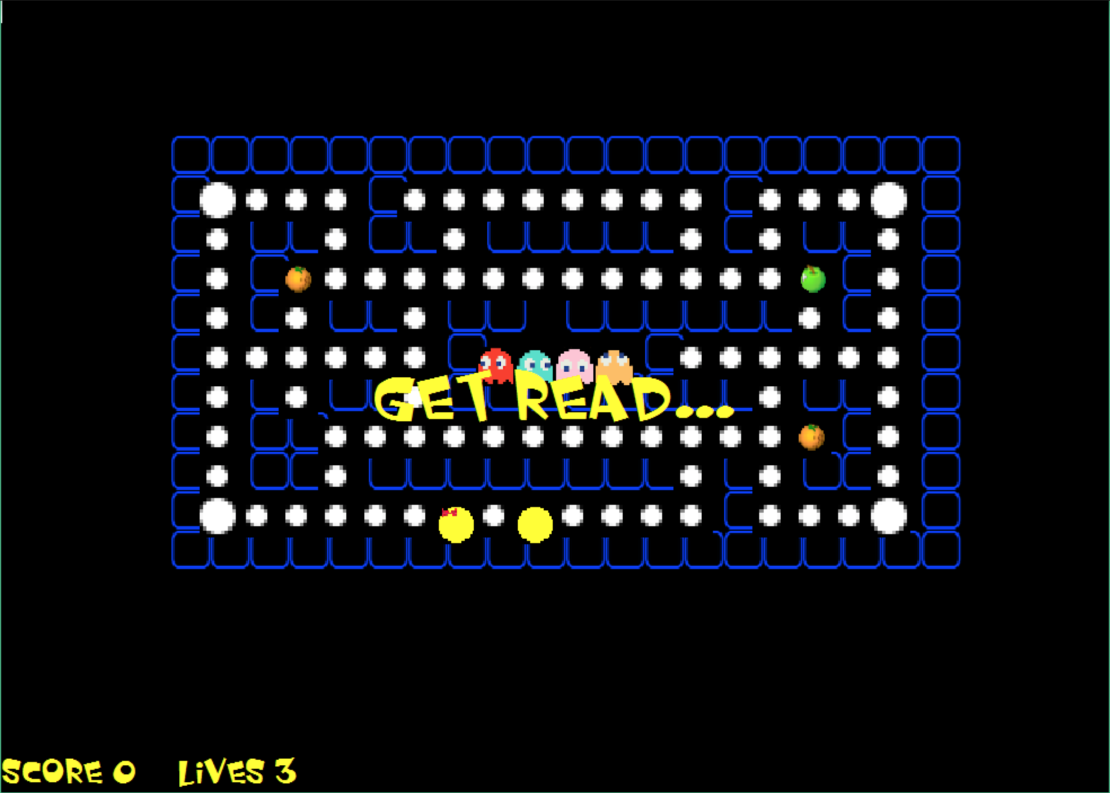

Pac-man can eat food and needs to avoid getting chaught by the ghosts. Two of the ghosts move *“silly”* in Pacman term and the other two are moving according to their moving algorithms. Single player and multiplayer views of the game is shown below.

*Single Player:*

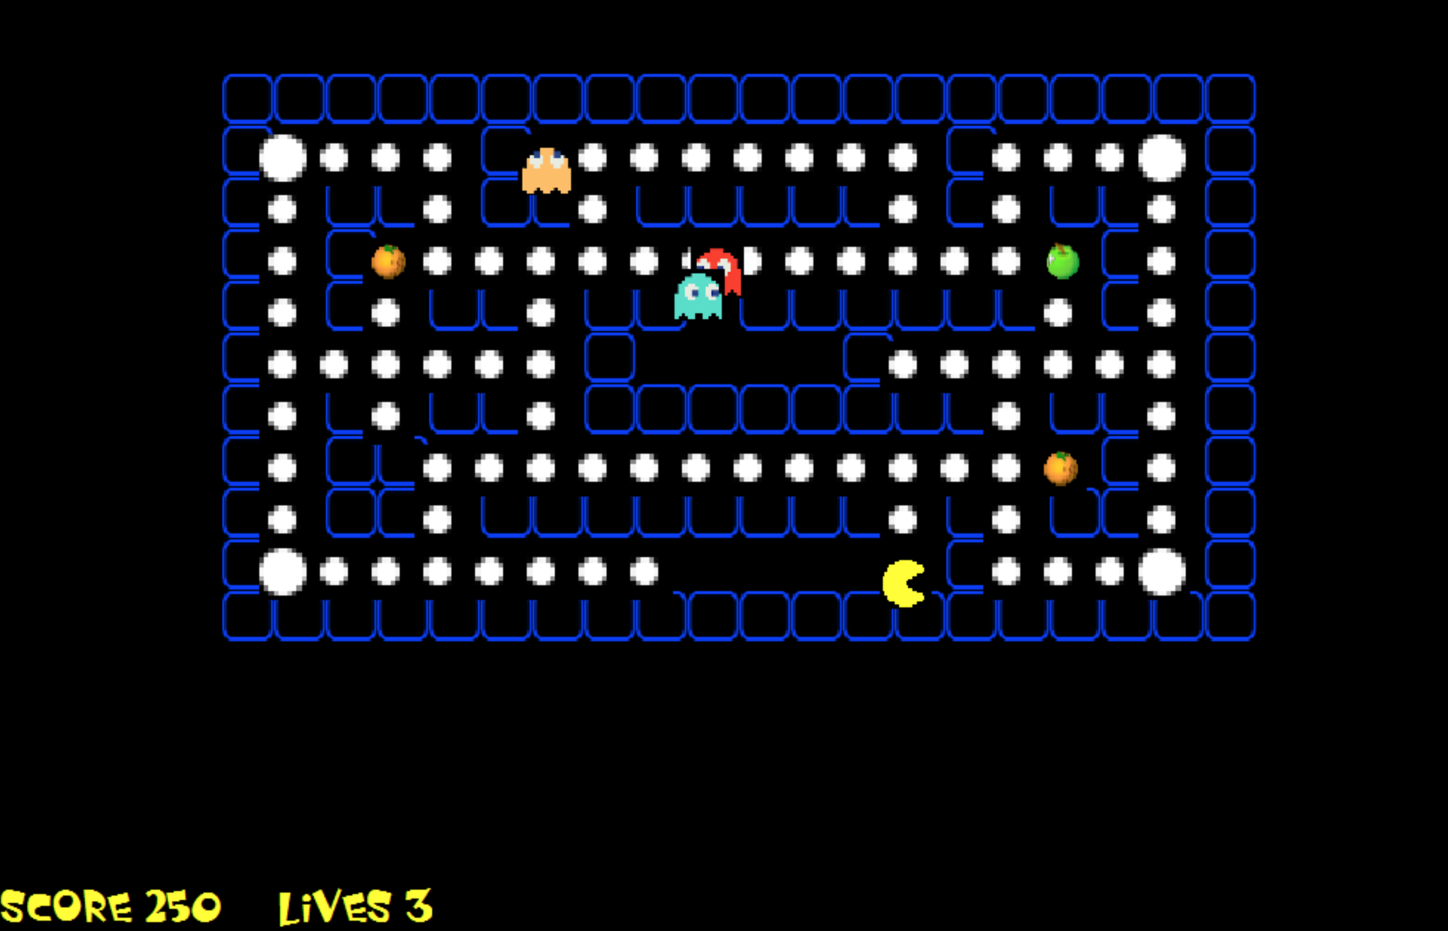

*Multi Player:*

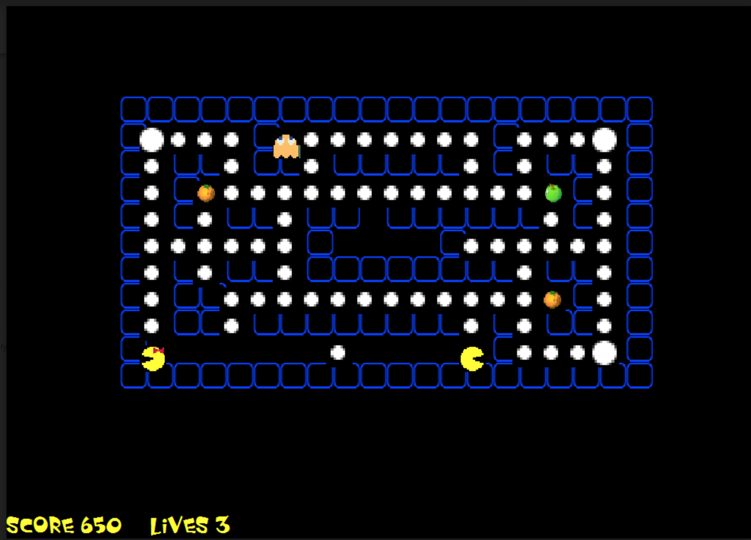

If the user wants to stop playing he can pause the game and he can also save the game to continue another time.

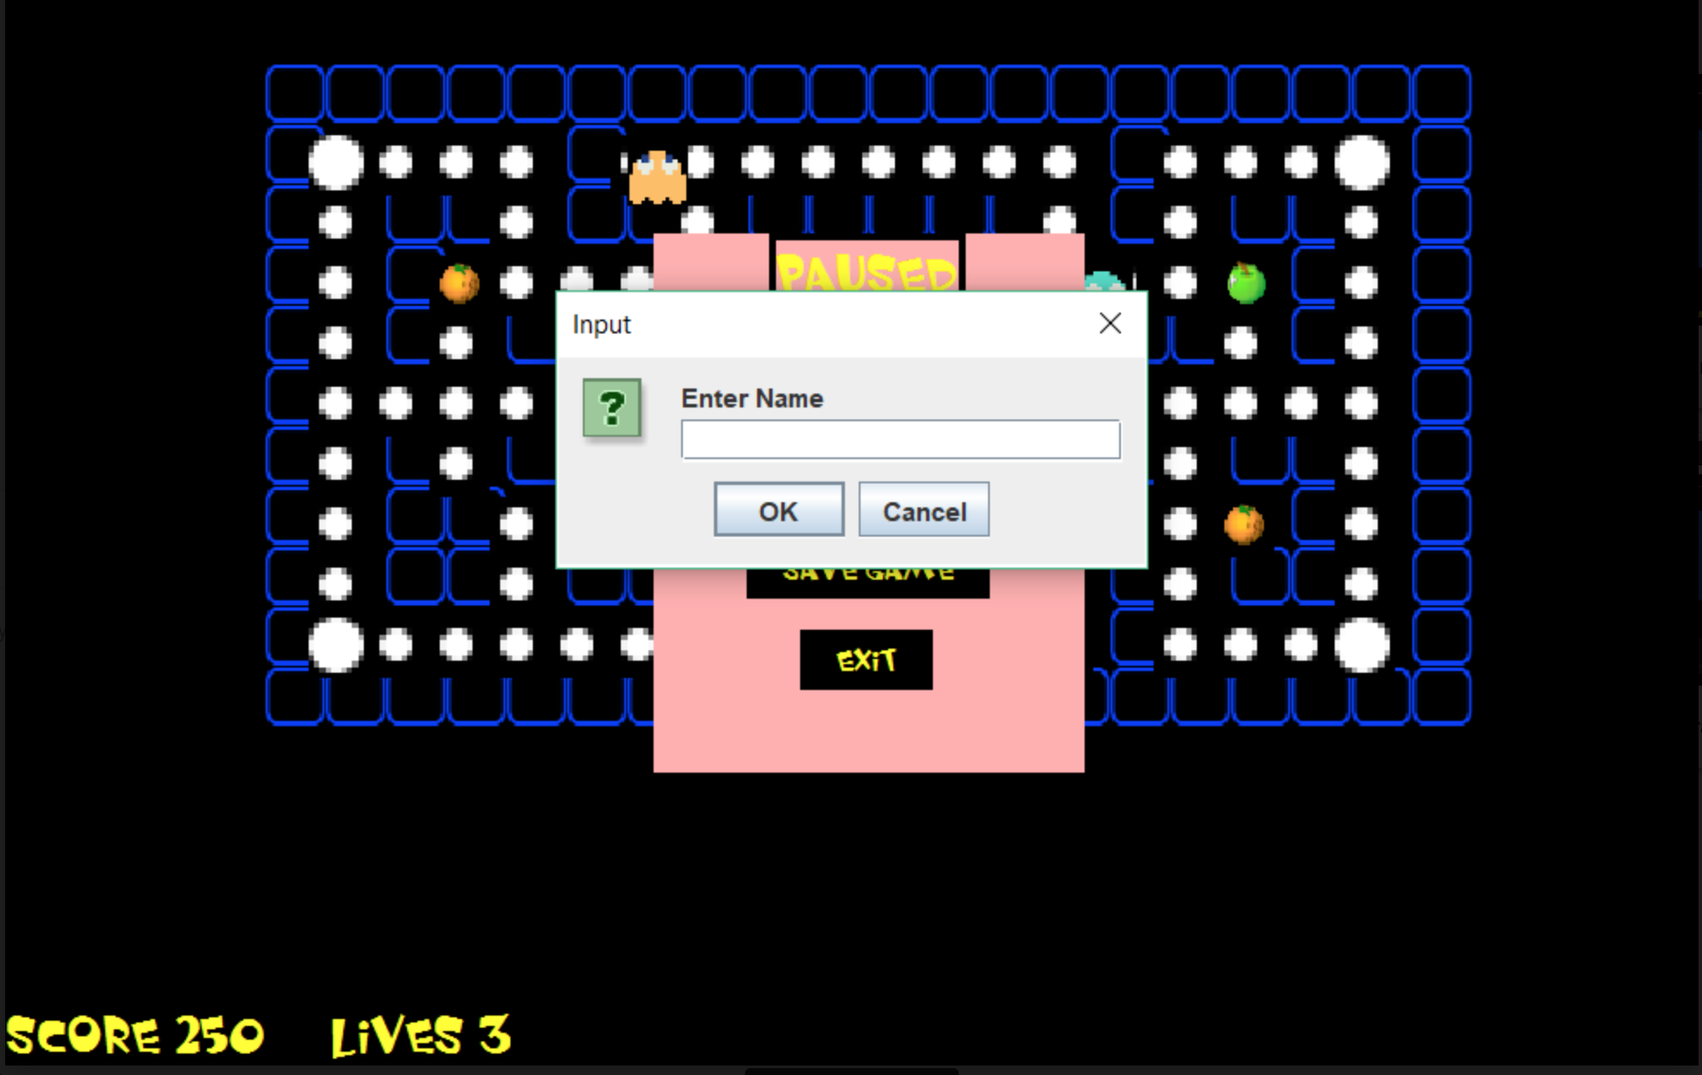

User can create his own map and he can either save it to play another time, or play it immediately. The building map mode is shown below.

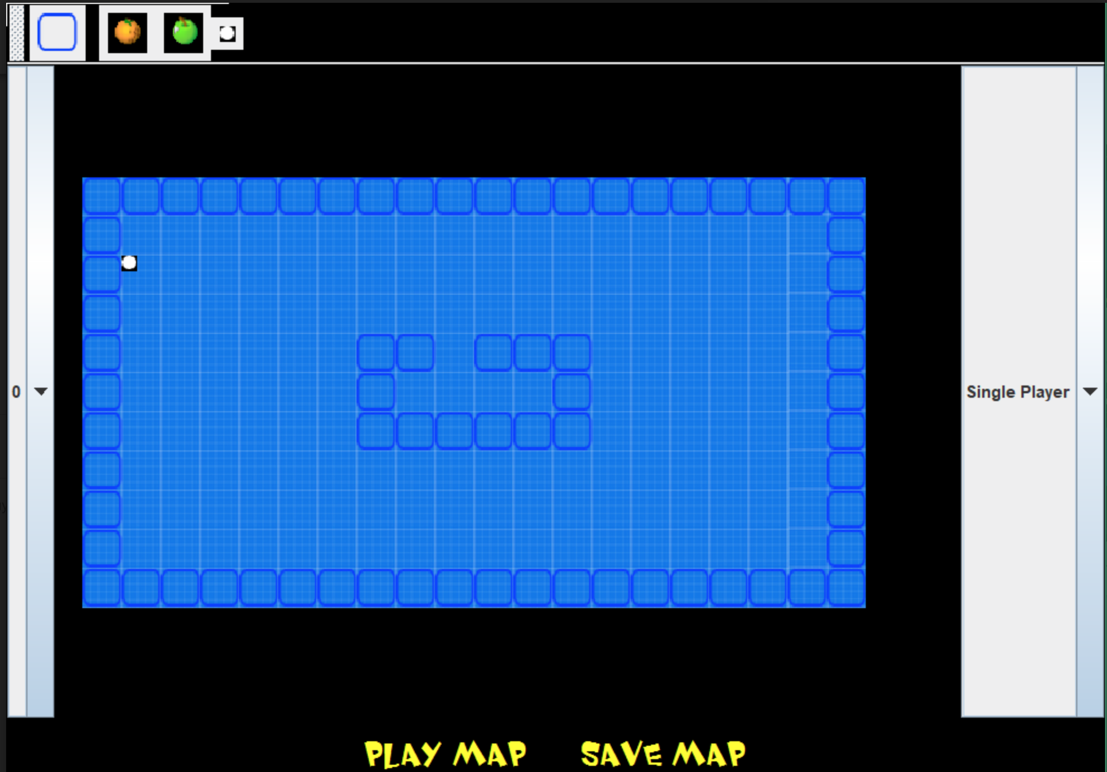

User can play the saved map by entering its name, which can be seen like below.

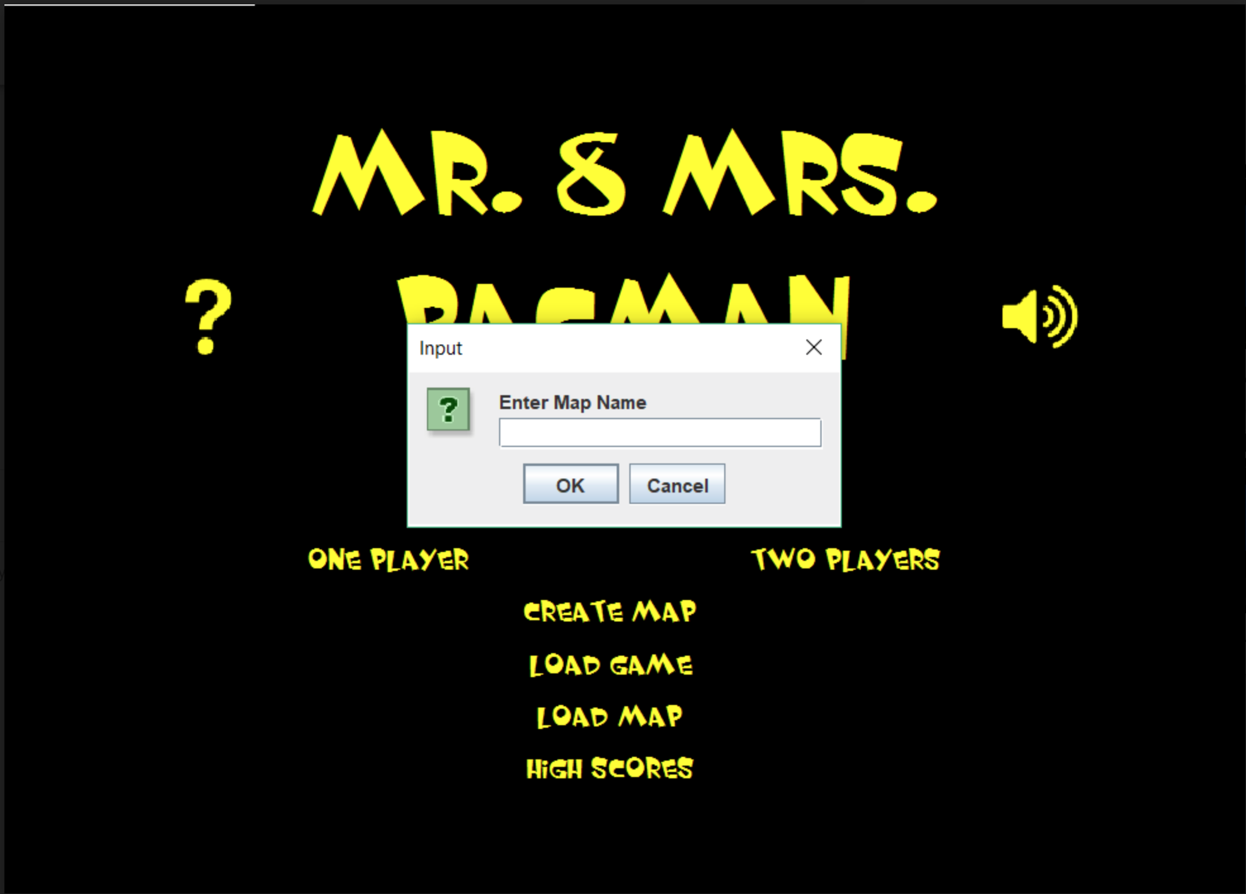

**3.4 Game Entities Subsystem**

**3.4.1 Game Screenshots**

***Animation Screen:*** The screen, which appears when the game launches.

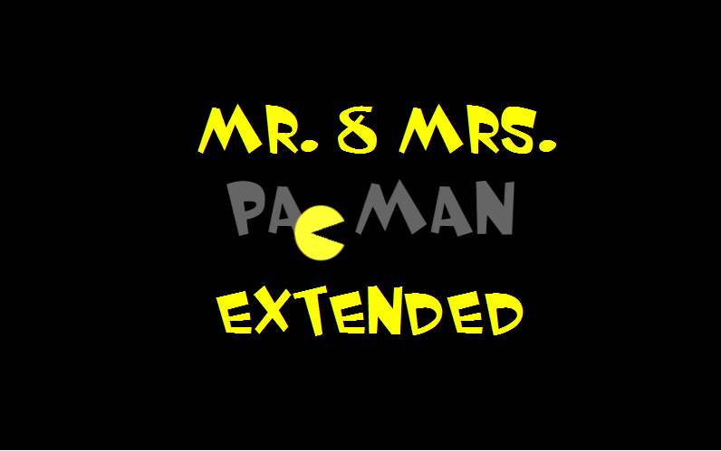

***Main Menu Screen:*** After animation this main menu screen appears.

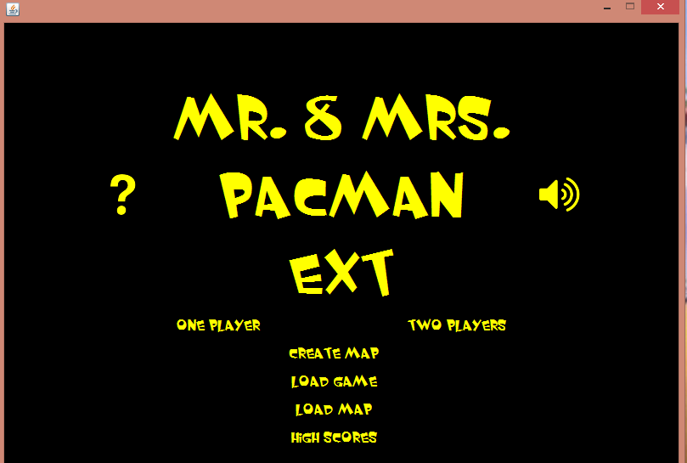

***Pause Menu:*** When player presses ‘ESC’ during the game, pause menu appears.

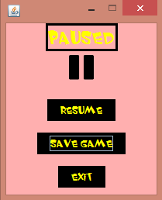

***Help Panel:*** If player clicks question mark on the main menu, help panel will appear.

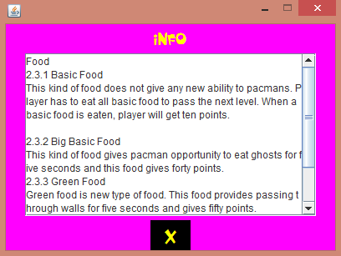

***Shield Menu:*** This panel will appear after first or second levels are completed.

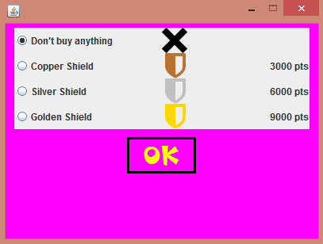

***Saved Games Panel:*** This menu shows list of the saved games. Player can play one of them.

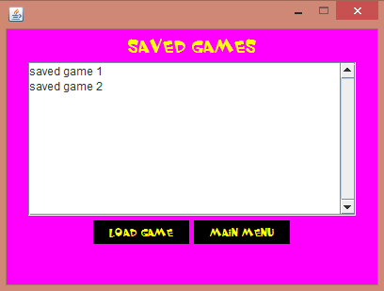

***High Score List:*** This list shows saved high scores.

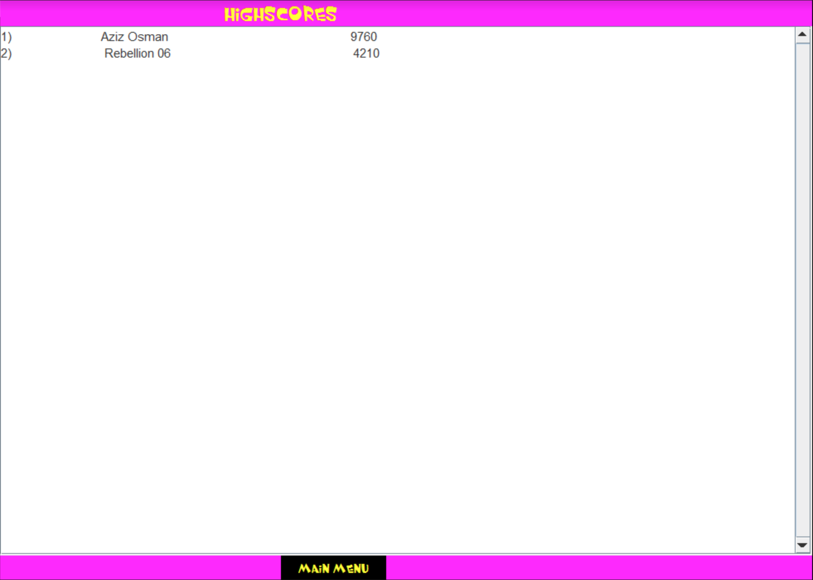

***Game Over:*** This page is end of the game and provides going back to main menu.

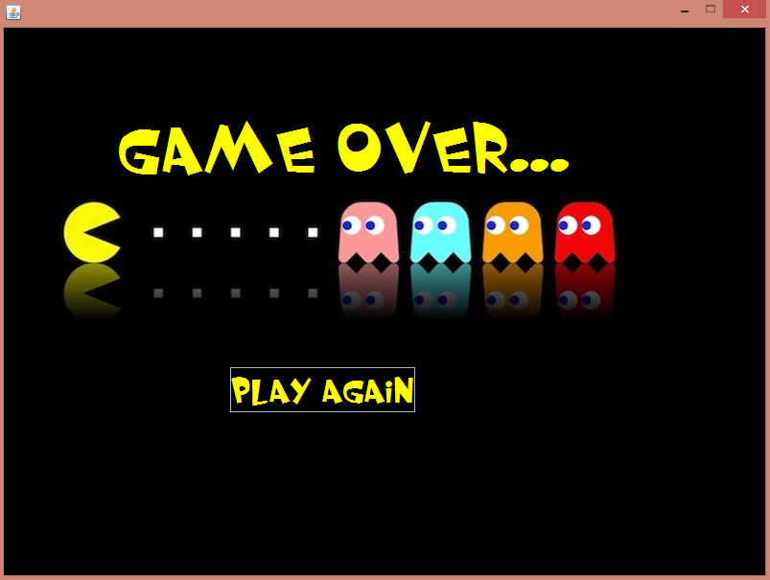

**3.4.2 Controls**

* Mrs. Pac-man: W, A, S, D

(W: up, A: left, S: down, D: right)

* Mr. Pac-man: Arrow keys

(↑: up, ←: left, ↓: down, →: right)

* ESC: Pause

**3.4.3 Game Objects**

* ***Mr. Pac-man:*** One of the main objects of the game. First player controls Mr. Pac-man with arrow keys.
* ***Mrs. Pac-man:*** Other main object of the game. Second player controls Mrs. Pac-man with W, A, S, D.
* ***Ghosts:*** They are enemies of the Pac-mans and they try to catch Pac-man. If they catch, Pac-man loses a life. If the Pac-man eats Big Food, the ghosts became eatable by Pac-man and they turn into an opportunity for user to gain score.
* ***Food:*** Food items are eatable by the Pac-mans. Different food types are giving different scores and side effects to the Pac-mans. There are basic, big, yellow and green types of food.
* ***Shield:*** Shields have three types: copper, silver and golden and the player can get them with using the collected score. Each of them gives different abilities to the Pac-man.

**A. Appendix**

1. User Guide:

https://github.com/talhaseker/Mr.-Mrs.-Pacman-Extended/blob/master/Reports/Users%20Guide.pdf